**CHANGE POSTING DATE**

1. Go to the run custom procedure menu option under System Administration (N-R).
2. Type in (util/changper.r) in the procedure box and click run.

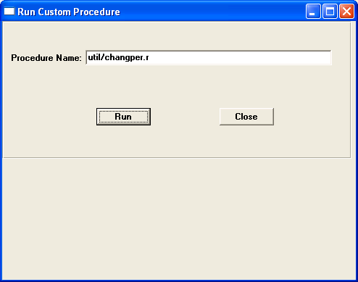

1. Enter the run# from the posting report that needs the posting date changed and then tab.
2. Change the New Date field to the new posting date.
3. Click start process and wait until the process is complete.

